User Manual

User Manual
The User Manual
The user manual is designed to provide a basic guide to the users of how to use the functions in the system. By showing screenshots and sample error messages with simple instructions, the users should become more adept while using the system.

System Requirements
Microsoft Operation System (Windows XP recommended)
Microsoft Office Version 2000 or after
Pentium® 4 800 MHz
128 MB RAM
500 MB Hard Drive

The Set-up Procedure
To begin with, the computer needs the executable file of the system and the database folder that contains the databases. These files can be found on the disk of installation. After inserting the disc, there will be a confirmation message asking the user whether he/she wants to copy the program and database onto the computer or not. The program will be copied to the path “C:\Program Files\D-Store\”. Under the D-Store folder, it will have the “D-Store.exe” and folder “Databases” with a sample database within as a hidden folder. There will also be a shortcut of D-Store.exe created on the desktop.

Starting The System
To start the system, double click the D-Store.exe icon.

User access right
This is set up to restrict some users from using some of the functions to the system. The default account has right of “Admin”, which has full access to the system. There are 3 other types of access right:
User: account for salesman, have access to make sales and orders, but no access to editing stock details
Stock: account for people in charge of stock, have access to editing stock details but no right to make sales and orders.
Both: account that has both the access right of status “User” and “Stock”.
Only admin users have access to the following functions: Managing user accounts, reports and backup/archive.
Content Page of User Manual

Log in

Mainmenu

User Acounts

Changing Pssword

Stock

Sales

Orders

Members

Statistics Reports

Backup/Archive Records

Errors

Using the System
Logging In
This is the first screen that you will see after clicking the D-Store.exe icon.
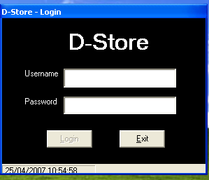
In order to login, you have to type in the correct username and password into the fields. The default username is “admin” and the password is “admin”.

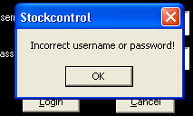
With incorrect username or password, an error message will come up saying “Incorrect username or password”

After login with the default account “admin”, user is allowed to create new accounts, changing password of the admin account or even deleting it. Remember, setting different user status gives the account different access right to the system. For further instructions please read the “User’s Form” section.

Mainmenu
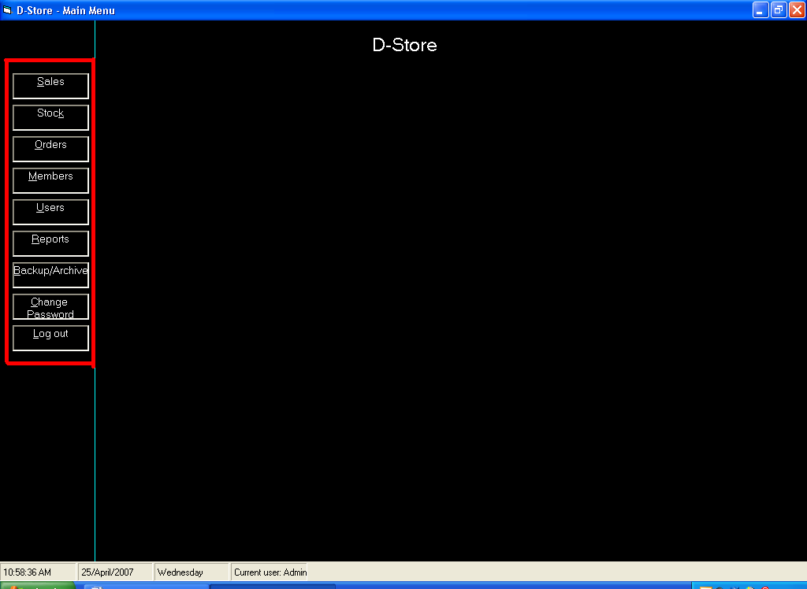
This is the mainmenu of the system. By clicking on the buttons on the left hand side, windows with different functions will pop up with in the right hand side of the

Managing user accounts
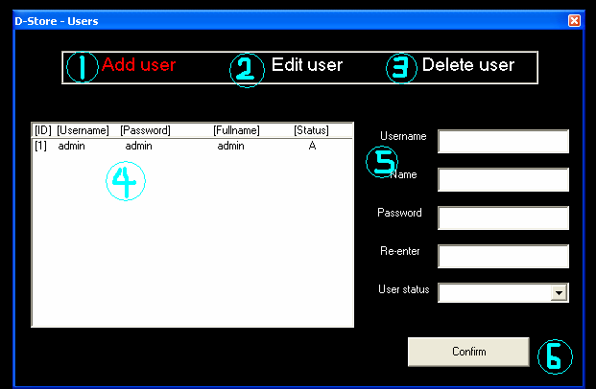
After first time login, user is adviced to change the password of the admin account, or deleting it after creating a new account of Admin status. The user form is visible to admin users only and allows the users to change the user status of an account, or deleting other accounts, but not the one in use. To change password of the using account, please read the “Change Password” section.

Adding a user account
Click on 1 (add user mode), then fill in all the information in the fields in 5, then click the confirm button on 6.

Editing user status
Click on 2 (edit user mode), then click on the user that you want to change the status on 4, change the status with retyping the password of that account, and click the confirm button on 6.

Deleting a user account
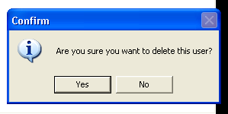
Click on 2 (edit user mode), then click on the user that wanted to be deleted on 4, click on 3 and there will be a confirmation message like this showing:
Click on yes to delete the account
Click on no to cancel deleting

Changing Password
To change the password of the currently using account, you have to type in the current password in the field old password, and type the password that you want to use twice, in the new password and confirm new password field. There is no minimum digit required, but for security reason users are adviced to have at least 8 digit of password consist of characters and numbers.
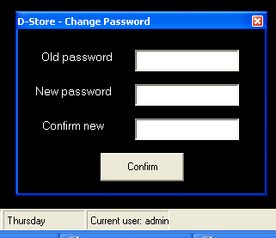
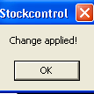
Message of changing password successfully.

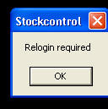
After the success on changing password, the system will log user out and require user to login again with the new password.

If the new password that user wanted to use is the same as the old password, then the system will not allow user to do so. The following message will come up instead of the change applied and re-login message:

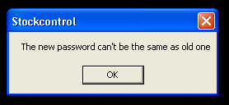

When the new passwords are not the same, the system will not allow user to change password. The following message will come up. User should retype both the new password and retype new password again.
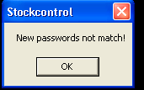

Stock
Before starting to make sales and orders, the details of stock must be entered into the system. This form is visible to all users but the user with the access right of “user” has not right to use button 1, 2 and 3.
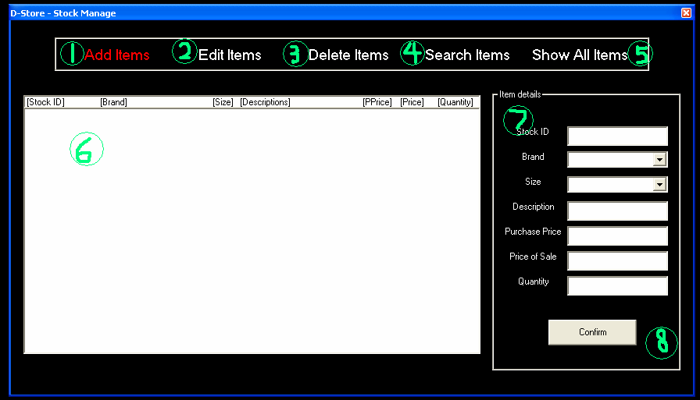
Add a new stock
Click on 1, fill in all details in 7, then click confirm on 8.

Edit stock details
Click on 2, choose a stock in 6, change the details in 7 and then click on 8 to confirm.

Delete stock details
Click on 2, choose a stock in 6, click 3 and a confirmation message will come up.
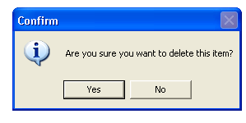
Click on yes to delete
Click on no to cancel deleting

Search stock
Click on 4, fill in search criteria in 7 (doesn’t need to fill in all fields), then click on 8. All stock that match the search criteria will show in 6.

Showing all stock
Click on 5 and all the stock details will be shown in 6.

Sales
After having stock details recorded, we can start making sales.
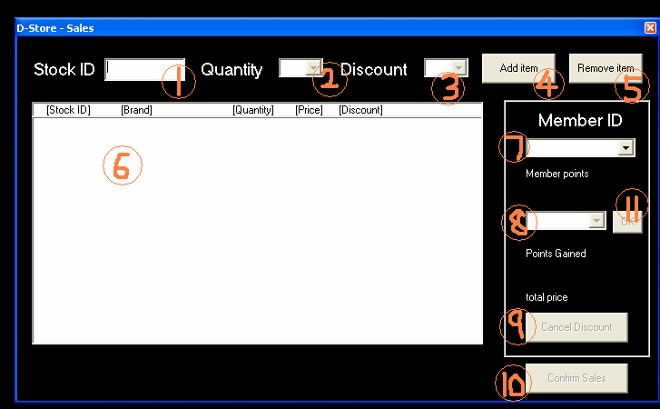

Adding item onto sale list
To start with, a stock ID is required, to be typed into 1. The system will then check that is it valid, and the stock quantity if is valid. The quantity allowed to make sale will be added into the quantity combo box in 2. After choosing a quantity, discount rate will be available for user to choose in 3, which is optional, and be sale on original price will left empty. Items can only be discounted when the quantity is one. Then click onto 4 to add the sale details onto 6.

Deleting an item from the sale list
Click on the unwanted item in 6, then click on 5 to remove the item from the list. Price and points gained will be recalculated even the item is discounted.

To use member point to discount an item
First choose a member from 7. The member points of that member will show below 7.
Then click on an item in 6. And then choose a discount rate in 8, click on 11.

To cancel discount on a discounted item
Click on the item in 6, then click 9. The price and points gained will be recalculated automatically.

To confirm sale
Click on 10 to confirm the sale. A receipt will be printed out.

Orders
To make an order, first click on the “Order” button on the menu of mainmenu. The following window should appear after you do so. This is the order form.
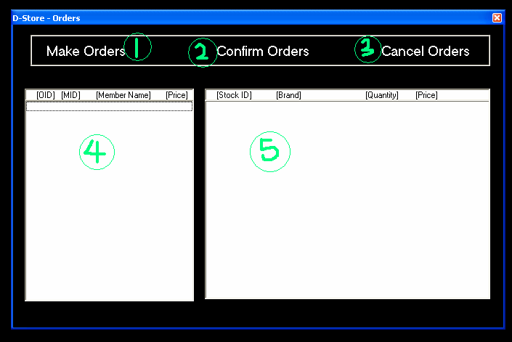

1 : Clicking on this button will show the form of adding items onto the order item list.
2 : To confirm an order that shows on the order list.
3 : To cancel an order that shows on the order list.
4 : Order list
5 : After clicking on the order in 4, items of that order will be shown.
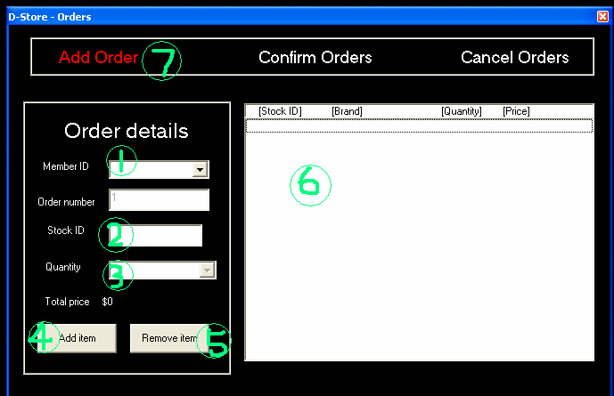

Making an order
First choose a member from 1. If there are no details of the member click on “create member”, which will shows the member form. See “Members” section. Then type in an stock ID in 2 and select a quantity in 3. Click on 4 to add the item to the list on 6. Click 5 to remove the item from the list 6 if the item is unwanted. After adding all items and chose an member, click on 7 to add the order. The items are then reserved for this member and wait for the confirmation from this member to include these items into sale record.
Members
This is the form of managing member details. This form allows user to create, editing, searching, but not deleting a member.
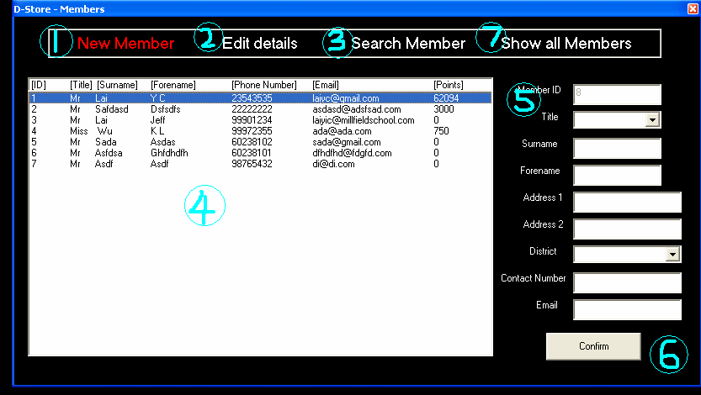

Adding new member
Click on 1 (enables the add member mode), fill in all details of the member in 5, click on the confirm button on 6.

Editing a member’s detail
Click on 2 (enables the edit mode), choose a member from 4. Edit the details in 5, then click on the confirm button on 6.

Searching a member with details
Click on 3 (enables the search mode), type in the search criteria (does not need to fill in all fields) in 5, click on the confirm button on 6 and the results of members that match the search criteria will show on 4.
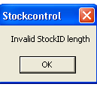
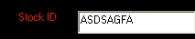
With invalid fields (such as invalid length of stock ID), an error message will come up when user clicks confirm button, as well as with the invalid field highlighted.

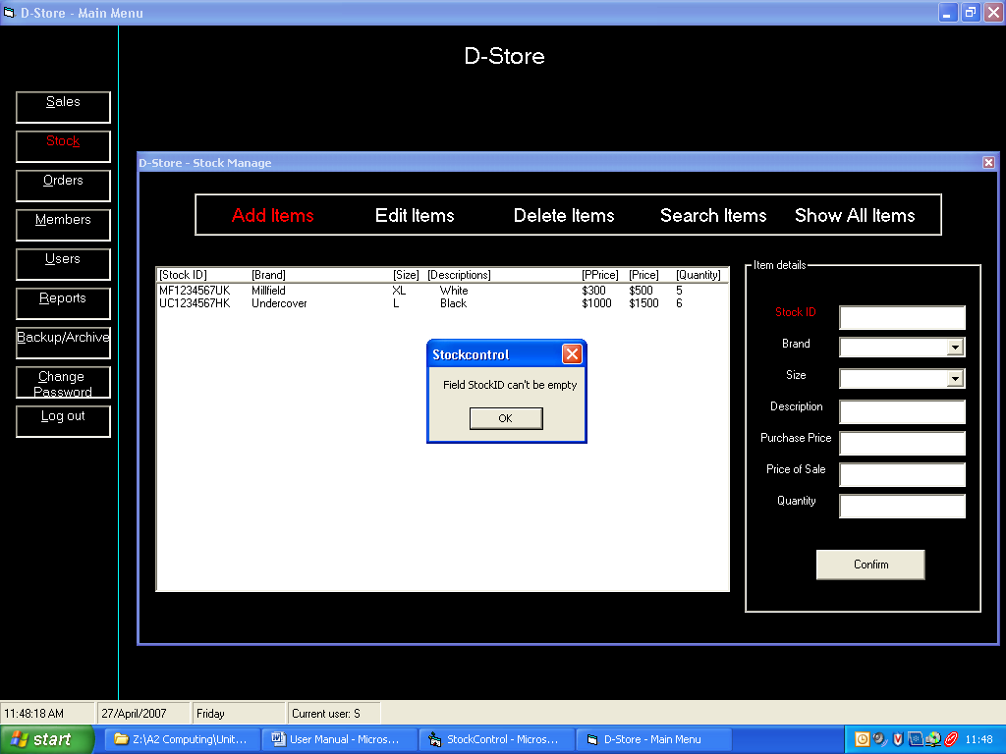
With empty fields, a n error message will come up when user clicks confirm button, as well as the empty field highlighted.

Statistic report
Admin users have the right to view the statistics for the month, or a chosen month.

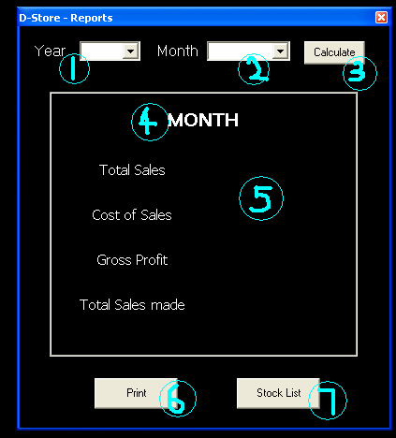
1: Combo box to choose the wanted year.
2: Combo box to choose the wanted month.
3: Calculates the statistics for the wanted month
4: Date of the statistic.
5: Statistics of that month
6: Prints the statistics out
7: Prints out a list of stock left

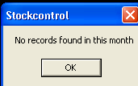
If no records is found for the recent month then this message will come up.

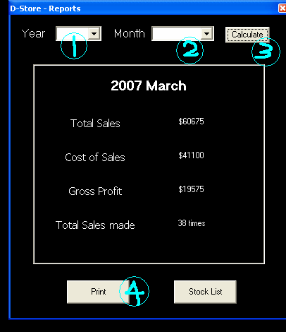

To calculate a chosen month’s statistics, follow the following steps:

1: Choose a year from the box
2: Choose a month that you are interested in
3: Click calculate and the system will automatically calculates the statistics.
4: If you want to print out the statistics, click on print. This will require a printer.

Backing up/Archiving records

This is another function that only admin users have access right to user. This function allows user to backup or archive records. However, to do so, user must have a USB drive, with .DAT file named “uniquedriveidentifier” on the drive. This can be found on the disc of installation.The system will not allow user to backup/archive records even a USB drive is plugged in, when without the .DAT file on the drive.
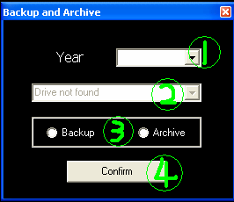
To backup/archive:
First choose a year from 1. Then plug in a USB drive that has the .DAT file “uniquedriveidentifier” on the drive. It will then be detected by the system and the drive letter will be shown in 2. Then choose to backup or archive in 3 and after you did it click on the confirm button to complete the backup/archive process.

Only one database will be backed up/archived at a time. The database(s) will be stored under root folder “databases” on the USB drive.

The database of the current year’s, however, would not be allowed to archive. The following message will come up and prevent it when users tried to do so.
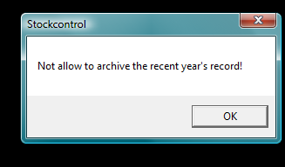

Errors that users may encounter
Invalid stock ID
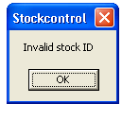
This is will come up when user typed in a stock ID that can not be found inside the database. This is likely to happen in case like user mistype the stock ID.

No stock
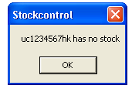
This will come up when user typed in a stock ID that has no stock at the moment.

Process stopped

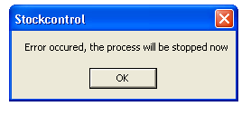
This is an error that is not very likely to come up. This means that the actually quantity available is smaller than the amount requested. This will happen when the user adds a certain quantity of an item that exceeds the total quantity in stock onto the sale list and order list (operating sale and order at the same time) and confirmed the order follow by confirming sale. This message is to prevent selling more stock than the actual quantity. The appear of this message means the sale is not completed.

Discount only allow for 1 item
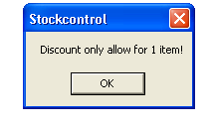
This message will appear when user attempt to discount an item that has quantity more than 1.

Only one item can be discounted
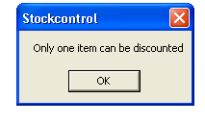
This message will appear when user attempt to discount an item that has quantity more than 1 with member points.

Invalid price
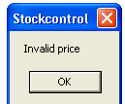
This message will appear when user attempt to set a price of an item for either $0, or $60000 and over in either of the fields Purchase Price or Price of Sale

